
:gf]Nof08 Plss[t ljsf; s]Gb|, g]kfn
Snowland Integrated Development Center [SIDC-Nepal]
Established 1992
Simkot, Humla
Tel 977-087-680059, Fax 977-087-6800059

Implementing Partner

ANNUAL PROGRESS REPORT

General Information:
Name of Implementing Partner | Snowland Integrated Development Center, Nepal
Project District | Humla
Project's Theme () | Livelihood | √ | Education
 | Health & WASH | √ | Sponsorship & CP
Project RM | Simkot RM, Kharpunath RM, Sarkegad RM & Chankheli RM
Reporting Period (MMDDYY) | January-December, 2025
Submission Date | December 31, 2025
Submitted by (Name/Position) | Karma Dhondup Lama ( Project Officer)

Contents
List of Acronyms 3
1. Background: 4
2. Activities in Details (Summary): 6
3. Major Achievement: 10
4. Activities in Details: 11
A. Social Economy: 11
1.1 Completed training on apple farming and nursery at Pokhri Cooperative, Sarkegad-5. 11
1.2 Input Support-Apple farming was provided to Pokhri Cooperative. 11
1.3 Completed Eco Friendly School Kitchen Garden at 8 Schools. 12
1.4 Supported Management support to 6 cooperative managers. 13
1.5 Three best-performing farmers were each awarded a vegetable and apple dryer. 13
1.6 A collection center was established in Simikot. 13
1.7 A small irrigation scheme was completed at Pokhri Cooperative. 14
1.8 Entrepreneurship training was completed. 15
1.9 Input and farming accessories support was provided to farmers. 15
1.10 A market actor coordination meeting was conducted. 16
1.11 Cooperative business management training was completed. 16
1.12 Cooperative accounting software renewal (AMC) cost was covered. 17
1.13 A district-level cooperative network meeting was conducted. 17
1.14 Office equipment and furniture support was provided to cooperatives. 17
1.15 A cooperative awareness campaign was conducted. 18
B. Health and WASH: 19
2.1 Completed Health and WASH education session at community 19
2.2 Completed Training to health workers 19
2.3 Maintenance works were carried out in three health posts. 20
2.4 General health check-ups were conducted for sponsored children. 20
2.5 A birthing center was constructed to strengthen health facilities. 21
2.6 Basic equipment was supplied to health facilities. 21
2.7 Utility support was provided to health facilities. 22
2.8 Training was provided to HFOMC members. 23
2.9 An MHM corner was established at Mandhara Secondary school. 23
2.10 An MHM-friendly toilet was constructed at the school. 24
24
2.11 MHM training sessions were conducted at the school. 24
2.12 Health and WASH education sessions were conducted at the school level. 25
2.13 FCHVs mobilization 25
2.14 Training on Health and WASH was provided to FCHVs. 26
C. Cross-Cutting 26
3.1 Training on Capacity building on climate-smart agriculture to farmers were conducted. 26
3.2 Natural Farming Demonstration center were formed in 10 places. 27
D. Non-POA Activities 27
4.1 Livelihood (In-kind) Support 27
4.2 Hygiene kit support 28
4.3 Critical treatment support 28
5. Financial Delivery: 29
6. Lesson Learned: 31
7. Issues and Challenges: 31
8. Way forward 32

List of Acronyms
NGO: Non-Governmental Organization
INGO: International Non-Governmental Organization
ICDP: Integrated Community Development Project
SMC: School Management Committee
PMC: Project Management Committee
SIDC: Snowland Integrated Development Center
GNI: Good Neighbor International
HKI: Helen Killer International
ORC: Outreach Clinic
DWS: Drinking Water Supply
ECD: Early Child Development
POA: Plan of Activity
RM: Rural Municipality
HH: Household
VPP: Vegetable Pocket Project
VC: Value Chain
HFOMC: Health Facility Operation Management Committee
SEP: Social Enterprise Project
RF: Revolving Fund
HP: Health Post
CHU: Community Health Unit
JTA: Junior Technical Assistant
CBDO: Cooperative Business Development Officer
FCHV: Female Community Health Volunteer
BHU: Basic Health Unit

1. Background:
Snowland Integrated Development Center (SIDC) is a leading non-profit non-governmental, autonomous, social development organization having the work based in Humla which is established in 1992. SIDC has been established by the local educated and the qualified residents with strong willingness and commitment possessing extensive experience in different sectors under the democratic pattern by holding the election in every 2 years by the general members for the representative of the executive body. The board comprises 9 executive members with a female chairperson including minimum of 33% of women representation. SIDC has been registered in the district administration in 1992 under the association and affiliation with the social welfare council and NGO federation of Nepal.

Several attempts were made by the different organizations in the past for the development of the Karnali. However, these were not found adequate to achieve the intended outputs and the results were still beyond our expectation because of the lack of the proper coordination and the knowledge about the typical land, place, and the people where they are culturally living. Seeing the lacks and efforts made in implementing different development endeavors in the region by many organizations in the past, there is a felt need to address equally in every aspect of development. So, SIDC is formed to fill the space being the bridge to the other stakeholders for progressive actions to bring out the concrete output in the field. Since then, people centered efforts were doing in proper co-operation, co-ordination, and collaboration in implementing different development activities in the region by governmental offices, national and international organizations and other interested agencies.

The constitution of SIDC has well defined set of objectives, goals, and mission to address the development equally in the district and to uplift the deprived community members who are Poor, Dalit, Ethnic and other marginalized people. SIDC realized and learned from the past development efforts because adequate attention was not given to identify the needs and demands of the community people, and they lack the utilization of resources (Human) available in the region. For this reason, SIDC make a well-set vision to identify the problems, needs and opportunities for proper utilization of the resources (Human) which are crucial for the sustainable development of Karnali. SIDC believes in collaborating with the agencies at local, district and national level and solid partnership with the civil societies, NGO/INGOs and federations at all levels to generate greater synergy on all its programs to contribute to meet the national goals and objectives. SIDC always tries to address and answering some of these important issues and promised to maintain the good relation among the people of the district for to make them empowered and make them participatory in the different fields of development.

Since its inception, SIDC has been working with the poor and marginalized people in rural Humla to empower them in the process of meeting their basic needs, improving livelihoods, and building their own socio-economic status upgraded. It has always focused on gender equality and the social inclusion. It has been success to maintain the good relation among the organizations and the people of the district for to make them empowered in the field like economic earnings, infra-structure, social mobilization, education, health and awareness, agriculture and husbandry, forestry, knowledge management and skill development. Besides the integrated activities of the development in the grassroots level, it is also engaged in communication, advocacy, lobbying, networking, and making the people more conscious at local and national level to promote the human rights and social justice.
Good Neighbor International Nepal has made its Project Agreement and General Agreement with Social Welfare 2021-2026, based on the Social Welfare Act and by law it has done agreement with SIDC, Humla to implement the Livelihood and Health Wash activities through SIDC project. The objectives of the Good Neighbor International are to increase equitable access and participation income generation process to improve the quality of livelihood status by supporting them in income generation and to strengthen more by the health and Wash activities.
SIDC Nepal is a reputed organization. It has worked in many sectors. It works on education, water and sanitation, health, livelihood, human rights and life skills climate change and such others many sectors. It has earned trust of the people. It made its first agreement with Good Neighbors International in 2016 to 2020 for five years. For second phase it has made agreement 2021 to 2026 AD.
Integrated Community Development Project (ICDP) has been implemented currently in four Rural Municipality (Chankheli, Sarkegad, Kharpunath and Simikot RM – former 16 VDCs of Humla district named Mimi, Darma, Shreemastha, Melchham, Gothi, Rodikot, Saya, Sarkideu, Barai, Lali, Kharpunath, Thehe, Bargaun, Raya, Chhipra and Simkot). The agreement is majorly focused on Health, WASH, Livelihood and Income-Generation activities. The following activities were completed from January to December 2025 in the respective fields, as part of the POA 2025 programs.

2. Activities in Details (Summary):

SN | Activities Name | Event |  | Program Date | Venue | Sector | No. of Beneficiaries
 |  |  |  |  |  |  | M | F | Total
Income Generation ( IG )-2025
1. | Input support-Apple Farming | 1 | May 2025 |  | Pokhri, Sarkegad RM | Social Economy | 120 | 150 | 270
2. | Training- Apple Farming | 1 | May 2025 |  | Pokhri, Sarkegadh RM | Social Economy | 120 | 150 | 270
3. | Cooperative Management Support | 1 | December 2025 |  | Sarkegad, Simkot and Kharpunath RM | Social Economy | 3 | 3 | 6
4. | Eco Friendly School Kitchen Garden | 8 | May 2025 |  | Simikot RM, Kharpunath RM & Sarkegad RM | Social Economy | - | - | -
5. | Vegetable and Apple Dryer | 3 | November 2025 |  | Simikot RM & Kharpunath RM | Social Economy | - | 3 | 3
6. | Collection Center Establishment | 1 | July 2025 |  | Simikot RM | Social Economy | - | - | -
7. | Small Irrigation Scheme | 1 | June 2025 |  | Sarkegad RM | Social Economy | 120 | 150 | 270
8 | Training- Entrepreneurship | 1 | September 2025 |  | Sarkegad RM | Social Economy | 7 | 43 | 50
9 | Input and farming accessories support | 1 | December 2025 |  | Sarkegad, Simkot and Kharpunath RM | Social Economy | 38 | 429 | 467
10 | Market Actor Coordination Meeting | 1 | August 2025 |  | Simikot RM | Social Economy | 22 | 16 | 38
11 | Cooperative Business Management Training | 1 | September 2025 |  | Kharpunath RM & Sarkegad RM | Social Economy | - | 146 | 146
12 | Cooperative Accounting Software Renewal (AMC) cost | 1 | July 2025 |  | Simikot RM | Social Economy | - | - | -
13 | District Level Cooperative Network Meeting | 1 | July 2025 |  | Simikot RM | Social Economy | 16 | 4 | 20
14 | Office equipment and furniture support to cooperative | 1 | July 2025 |  | Simikot RM, Kharpunath RM & Sarkegad RM | Social Economy | - | - | -
15 | Cooperative awareness campaign | 1 | July 2025 |  | Simikot RM, Kharpunath RM & Sarkegad RM | Social Economy | 71 | 84 | 155
Health & WASH-2025
1 | General health check-up of sponsored children | 1645 | December 2025 |  | Kharpunath, Simkot & Sarkegad RM | Health and WASH | 738 | 907 | 1645
2 | Construction of health facilities (Birthing center) | 1 | December 2025 |  | Simikot RM | Health and WASH | - | - | -
3 | Basic equipment support to health facilities | 2 | June 2025 |  | Kharpunath, Simkot, Sarkegad & Chankheli RM | Health and WASH | 842 | 1070 | 1912
4 | Utility support to health facilities | 1 | December 2025 |  | Simikot RM | Health and WASH | - | - | -
5 | Training to HFOMC members | 3 | July December |  | Kharpunath & Simkot RM | Health and WASH | 17 | 10 | 27
6 | Training to health workers | 2 | May 2025 |  | Kharpunath, Simkot & Sarkegad RM | Health and WASH | 27 | 17 | 44
7 | Establishment of MHM corner at school | 1 | June 2025 |  | Kharpunath RM | Health and WASH | 105 | 95 | 200
8 | Construction of MHM friendly toilet at school | 1 | November 2025 |  | Kharpunath RM | Health and WASH | - | 97 | 97
9 | Training on MHM at school | 2 | September 2025 |  | Simikot RM | Health and WASH | - | 70 | 70
10 | Conduct health and WASH education session at community | 4 | May 2025 |  | Sarkegad, Simkot and Kharpunath RM | Health and WASH | 32 | 76 | 108
11 | Conduct health and WASH education session at school | 3 | May 2025 |  | Sarkegad, Simkot and Kharpunath RM | Health and WASH | 32 | 76 | 108
12 | Training to FCHV on Health & WASH | 2 | July 2025 |  | Kharpunath RM | Health and WASH | - | 27 | 27
13 | FCHV mobilization | 2 | September 2025 |  | Kharpunath RM | Health and WASH | - | 27 | 27
14 | Health post Maintenance | 3 | February 2025 |  | Simikot RM and Kharpunath RM | Health and WASH | - | - | -

3. Major Achievement:
Project's Theme | Major achievement
Social Economy | - Training on apple farming and nursery management was completed at Pokhri Cooperative.  - Input support- Apple farming was provided to Pokhri cooperative.  - Management support was provided to 6 cooperative managers.  - Eco-friendly school kitchen gardens were established in 8 schools  - Three best-performing farmers were each awarded a vegetable and apple dryer.  - A collection center was established in Simikot.  - A small irrigation scheme was completed at Pokhri Cooperative.  - Entrepreneurship training was completed.  - Input and farming accessories support was provided to farmers.  - A market actor coordination meeting was conducted.  - Cooperative business management training was completed.  - Cooperative accounting software renewal (AMC) cost was covered.  - A district-level cooperative network meeting was conducted.  - Office equipment and furniture support was provided to cooperatives.  - A cooperative awareness campaign was conducted.
Health & WASH | - Health and WASH education sessions were conducted at the community level.  - Training was provided to health workers.  - Maintenance works were carried out in three health posts.  - General health check-ups were conducted for sponsored children.  - A birthing center was constructed to strengthen health facilities.  - Basic equipment was supplied to health facilities.  - Utility support was provided to health facilities.  - Training was provided to HFOMC members.  - An MHM corner was established at the school.  - An MHM-friendly toilet was constructed at the school.  - MHM training sessions were conducted at the school.  - Health and WASH education sessions were conducted at the school level.  - FCHVs mobilization.  - Training on Health and WASH was provided to FCHVs.
Cross Cutting | - Training on Capacity building on climate-smart agriculture to farmers were conducted.  - Natural Farming Demonstration center were formed in 10 places.
Non-POA Activities | 1. Livelihood (In-kind) Support  2. Hygiene kit support  3. Critical treatment support

4. Activities in Details:

A. Social Economy:

1.1 Completed training on apple farming and nursery at Pokhri Cooperative, Sarkegad-5.
The Integrated Community Development Project, with support from Good Neighbors International Nepal (GNI Nepal), has successfully completed the Pokhri Agriculture Cooperative in establishing an apple nursery and helping cooperative apple farming. This initiative aimed to improve farmers' capacity in apple cultivation through complete training covering nursery establishment, seed selection, grafting techniques, irrigation practices, composting, and pest management. Additionally, the project focused on sustainable practices such as mulching, drought relief strategies, and methods for propagating and marketing nursery plants. By training farmers with these skills, the project not only aimed to improve agricultural practices but also wanted to increase the cooperative's income through the sale of apple products, thereby contributing to the economic empowerment of the community. This event was completed in May 2025.
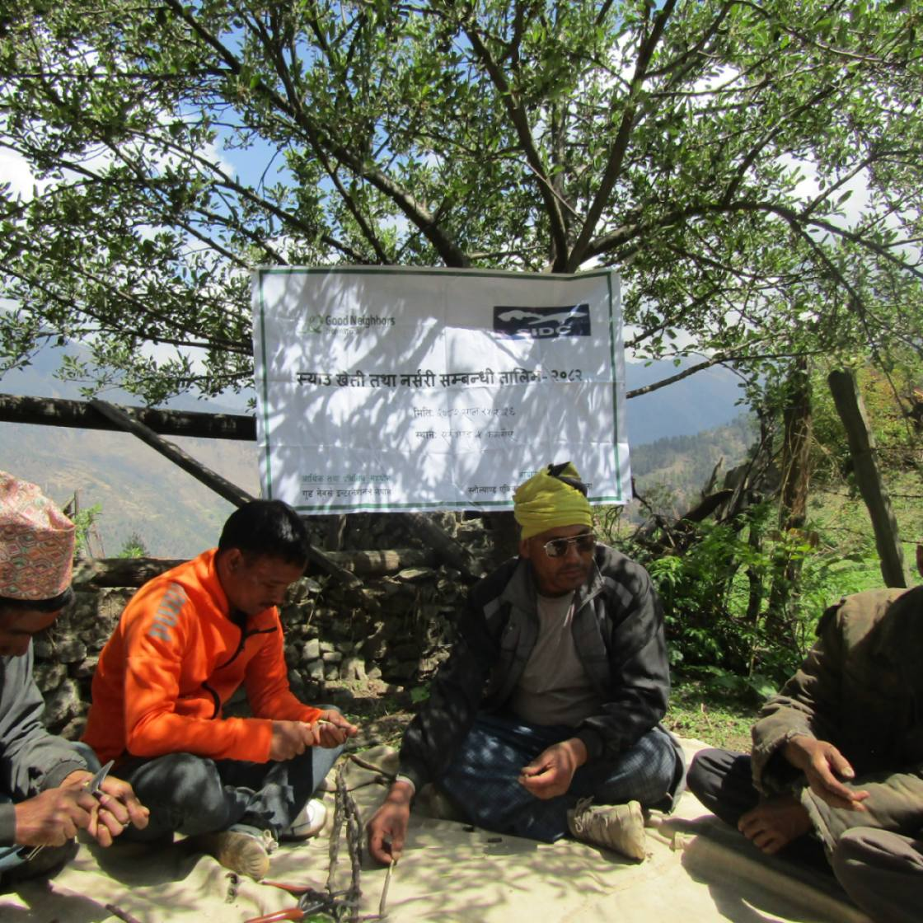
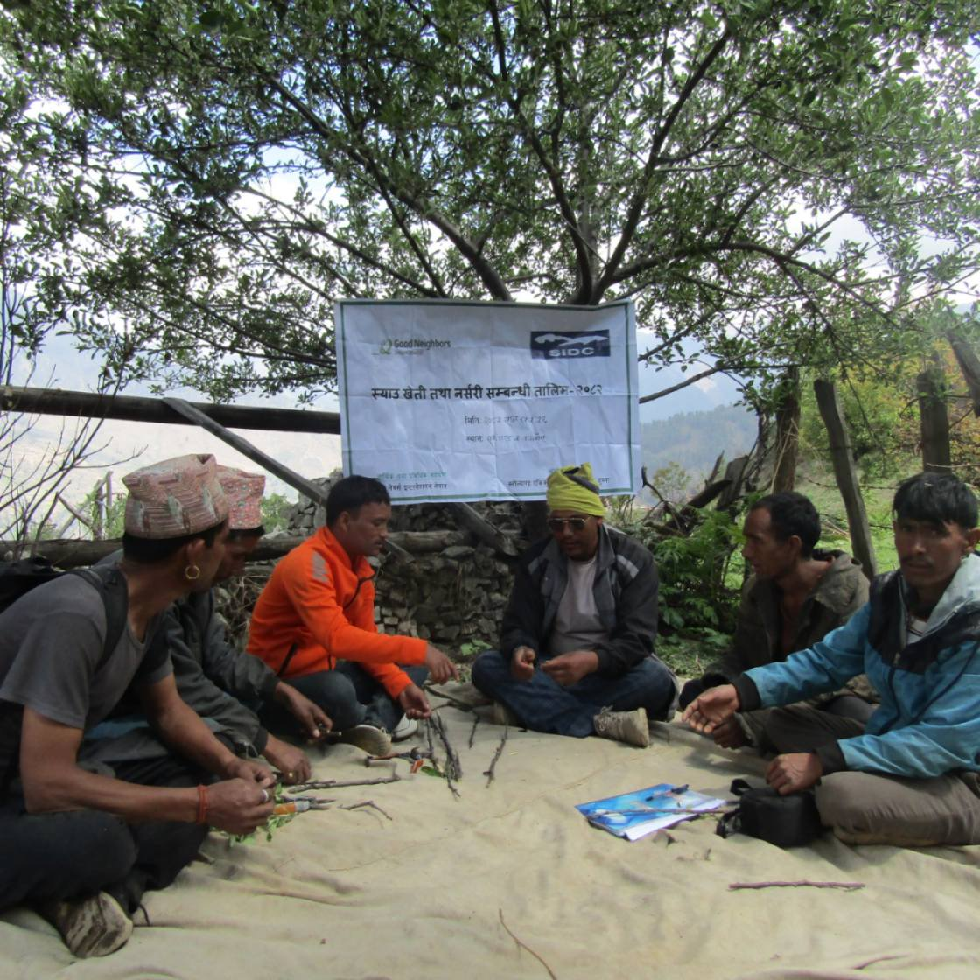

1.2 Input Support-Apple farming was provided to Pokhri Cooperative.
In May 2025, the Integrated Community Development Project supported Pokhri Agriculture Cooperative in establishing an apple nursery to promote sustainable farming and cooperative-based business development. The initiative focused on strengthening farmers’ skills in apple cultivation, including nursery establishment, seed selection, grafting, irrigation, composting, and orchard management. To support these activities, the cooperative was provided with essential materials such as Edimel seeds, a grafting machine, grafting knives, 50-meter garden pipes, and Bordeaux mixture. Through this collaborative effort, the project aimed to enhance income opportunities for cooperative members and contribute to overall community development.
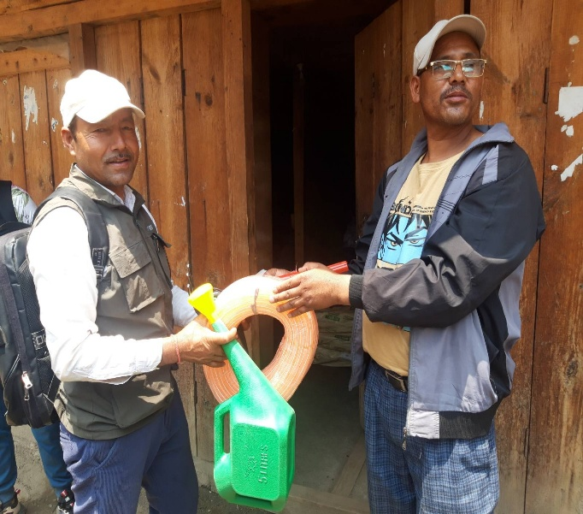
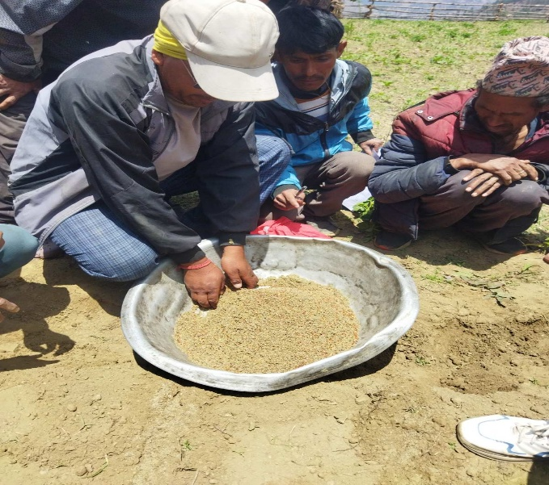

1.3 Completed Eco Friendly School Kitchen Garden at 8 Schools.
Snowland Integrated Development Center (SIDC), with financial and technical support from Good Neighbors International Nepal (GNI Nepal), has successfully completed in establishing eco-friendly school kitchen gardens and distributing seeds across eight schools in Humla District. The participating schools are: Kailash Secondary School (Simkot-7, Dadaphaya), Dulli Lower Secondary School (Sarkegad-4, Dulli), Bhawani Lower Secondary School (Sarkegad-5, Gothi), Malika Secondary School (Kharpunath-1, Lali), Mandhara Secondary School (Kharpunath-5, Kharpelgaun), Dhumchuli Primary School (Sarkegad-5, Bhuwakallash), Kailash Secondary School (Kharpunath-1, Pyusha), and Manshrowar Girls Hostel (Simkot-5, Tallobazzar).The main objective of this program is to promote nutrition awareness in schools and support the School Meal Program by producing vegetables in the school's own field. Some schools operate day and night boarding facilities for students from outside the community. This initiative aims to produce the vegetables required for the school's hostel and also increase income by selling excess vegetables in the nearest market. This initiative is completed in May 2025.
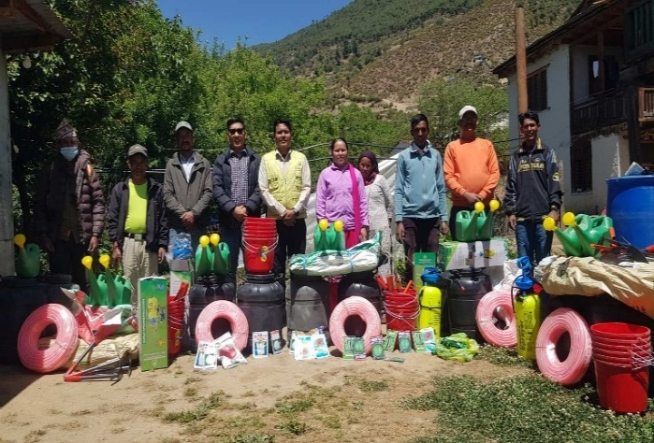
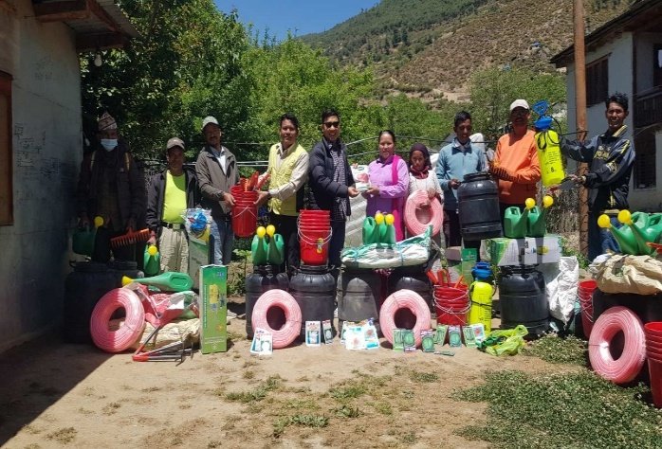

1.4 Supported Management support to 6 cooperative managers.

The activity was planned for 6 cooperative managers namely (Panchamukhi Dudedaha agriculture cooperative, Mastadev agriculture cooperative, Dudhkunda mahila multipurpose cooperative, Pokhri agriculture cooperative, Himali Organic Agriculture cooperative and Karnali Dovan agriculture cooperative) to motive them to do better and for systematic management of the cooperative. The objective of the activity is to promote effective, maintaining the 4 ledger accounts and timely reporting as well as actual report keeping for the transparency. The support was from January to March 2025 for 6 cooperative managers.

1.5 Three best-performing farmers were each awarded a vegetable and apple dryer.

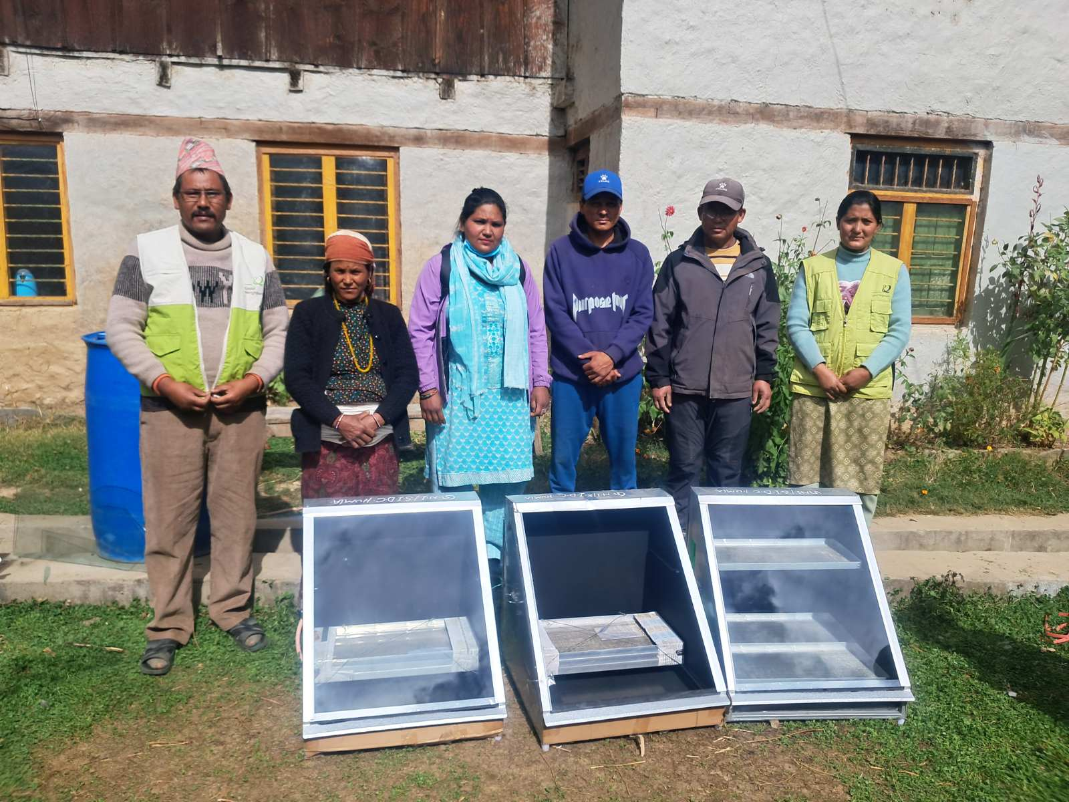
With financial and technical support from Good Neighbors International Nepal (GNI Nepal) and in collaboration with the Snowland Integrated Development Center (SIDC), solar dryers were distributed under the Integrated Community Development Project (ICDP) in Humla District to Geeta Rokaya (Simikot-3, Tallogaun), Motisila Rawal (Kharpunath-4, Chhipra), and Ragu Shahi (Kharpunath-4, Nalna). The support recognized their strong adoption of natural farming techniques promoted by GNI Nepal and SIDC. Their improved production has set a positive example for other farmers in the village. This activity was carried out in November 2025.

1.6 A collection center was established in Simikot.
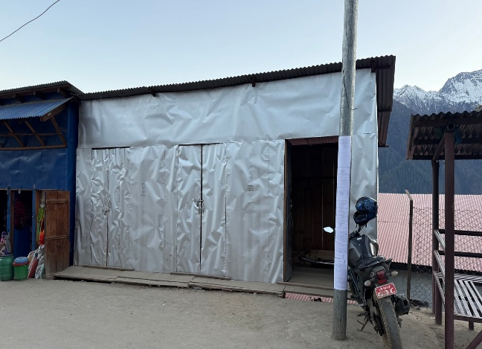
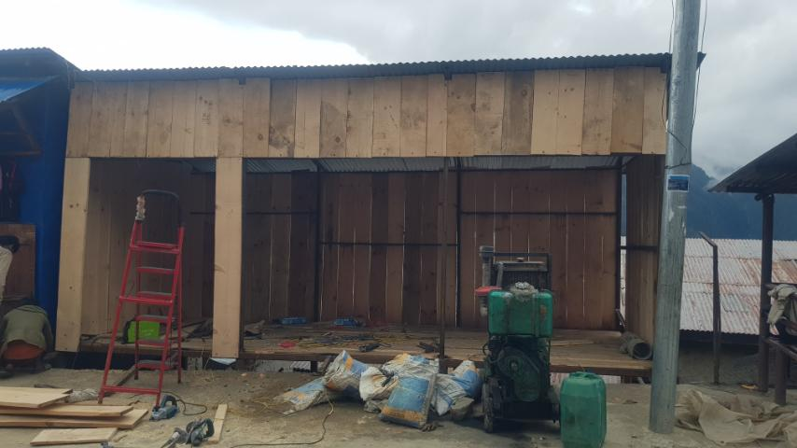
In collaboration with Simikot Rural Municipality, a vegetable collection center was constructed at the central location of the district headquarters. Both parties shared responsibilities for implementation, supervision, and overall management of the project. The primary objective of this initiative was to provide farmers with a designated space to sell their produce through the collection center. The construction was completed in July 2025.

1.7 A small irrigation scheme was completed at Pokhri Cooperative.

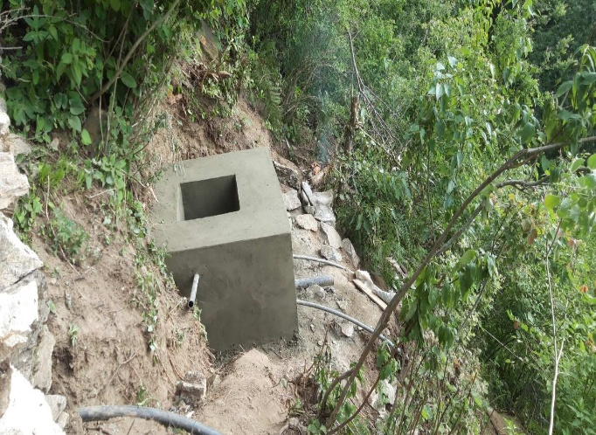
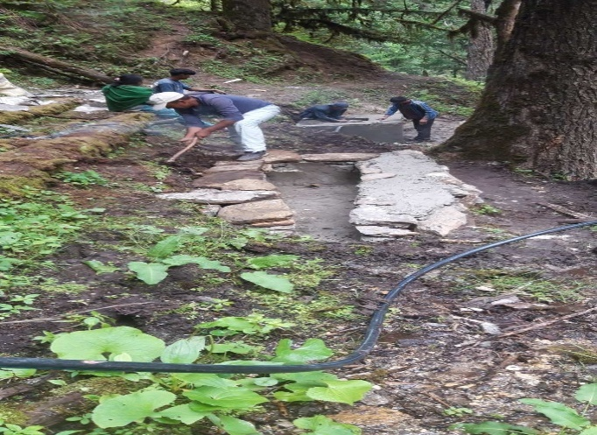
The construction of a small irrigation scheme in Sarkegad Rural Municipality, Ward No. 5, Kallash was completed in June 2025, covering approximately 1,210 meters from the water source to the farms. The scheme directly benefits 270 members of Pokhri Cooperative, including 150 sponsored households, and supports an apple orchard with 62 surviving trees that are three years old and previously affected by lack of irrigation. It also aims to improve apple production and increase yields of vegetables and field crops across nearly 60 ropani of land. The cooperative is responsible for the construction, operation, and maintenance of the system, ensuring long-term sustainability, improved income through crop diversification, and reduced reliance on rainfall

1.8 Entrepreneurship training was completed.

The Integrated Community Development Project organized a one-day training for selected farmers of Karnali Dovan Cooperative (Saya Group) to build their capacity in agricultural entrepreneurship by introducing the concept of enterprise, distinguishing enterprise from entrepreneurship, identifying characteristics of successful entrepreneurs, and guiding participants through a self-appraisal (preference) exercise. The training was facilitated by project officers and junior technicians and was successfully completed in September 2025.
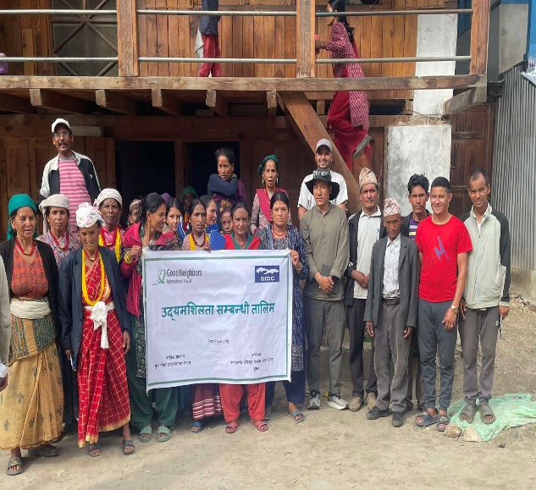
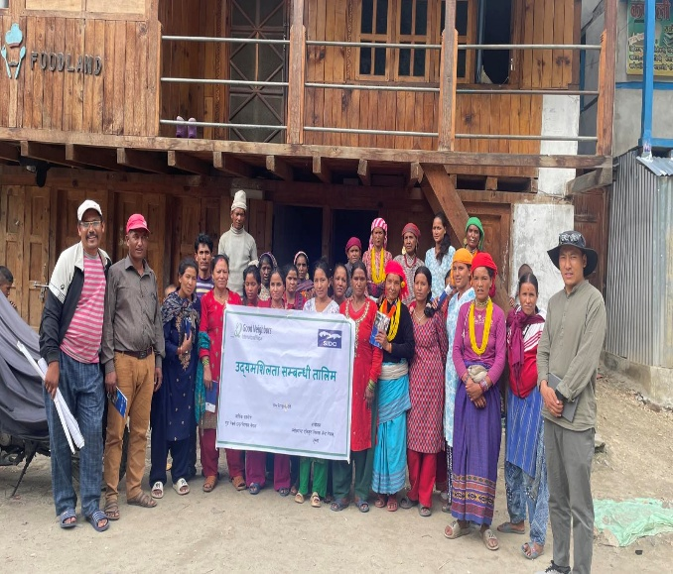

1.9 Input and farming accessories support was provided to farmers.
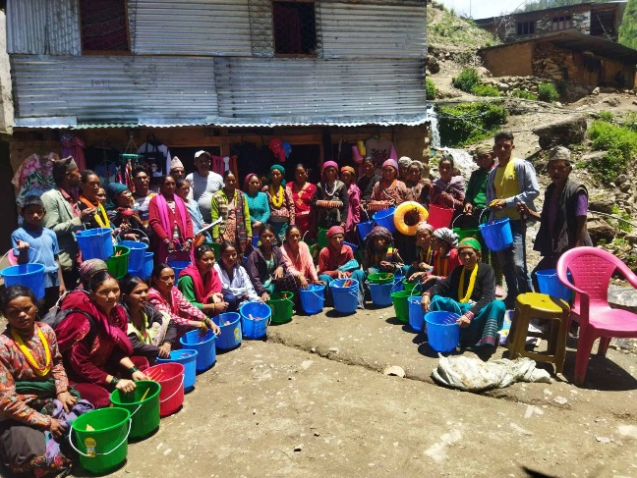
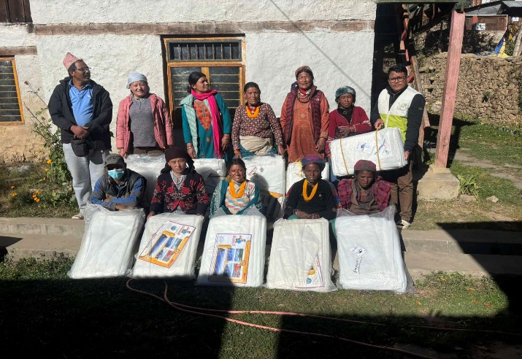
As planned under the Integrated Community Development Project, seasonal seed distribution was implemented in two phases, with the first lot completed in July 2025 for the rainy season and the second lot conducted in August 2025. The first phase supported 467 farmers from four cooperatives - Panchamukhi, Mastadev, Dudhakunda, and Karnali along with five schools and ten Natural Demonstration Centers to ensure timely access to quality seeds for improved nutrition and income generation. In the second phase, essential farming tools and seeds were provided to 207 new cooperative members, including 140 from Sarkegad Rural Municipality, 50 from Kharpunath Rural Municipality, and 17 from Simikot Rural Municipality. Additionally, 38 farmers were supported with silpaulin sheets under a cost-sharing scheme of 60% GNI Nepal and 40% by the farmers.

1.10 A market actor coordination meeting was conducted.
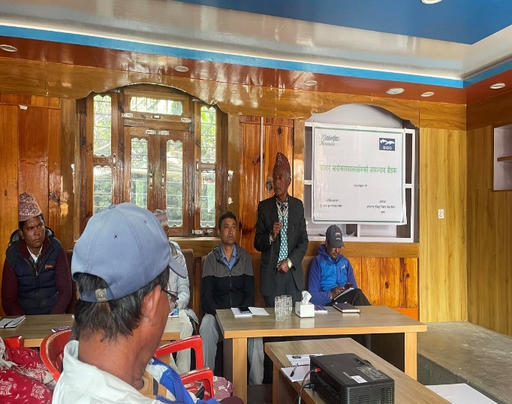
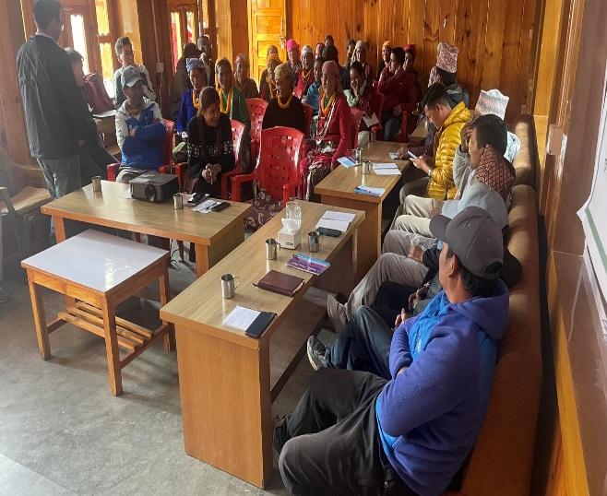
In August 2025, a Market Actor Coordination Meeting was held with 38 participants, including office staff, the Chairperson, Deputy Chairperson, Chief Administrative Officer, and Agriculture Officer from Simikot Rural Municipality; six farmers (including one Chairperson) from each of the three cooperatives—Panchamukhi, Masthadev, and Dudhkunda; one District Agriculture Officer; and five vegetable vendors. The meeting aimed to establish a management team for the efficient operation of the collection center and to strengthen market linkages for local products.

1.11 Cooperative business management training was completed.
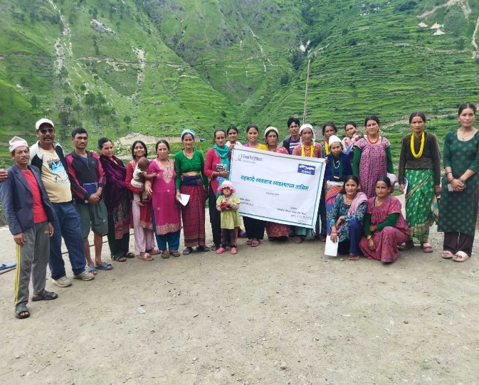
A one-day Cooperative Business Management Training was conducted for selected farmers from two cooperatives—Karnali and Dudhkunda. The training aimed to strengthen participants’ capacity in agricultural business development, going beyond merely accessing funds, by introducing basic business concepts, discussing various cooperative business models, identifying traits of successful entrepreneurs, and guiding participants through a self-appraisal exercise. The training was facilitated by project officers and junior technicians and were successfully completed in September 2025.
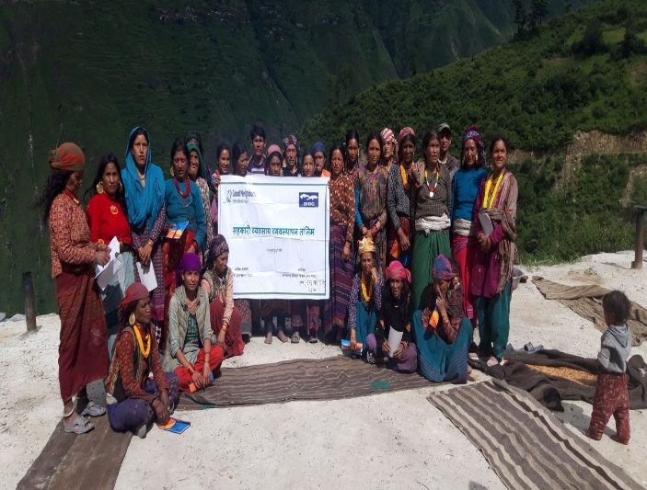

1.12 Cooperative accounting software renewal (AMC) cost was covered.
With financial and technical support from Good Neighbors International Nepal and in collaboration with Snowland Integrated Development Center (SIDC), support was provided to Masthadev Cooperative to cover the software renewal cost, which was completed in July 2025. The primary objective of this initiative was to familiarize cooperative members with updated technology in order to streamline operations, enhance efficiency, and simplify work processes.

1.13 A district-level cooperative network meeting was conducted.
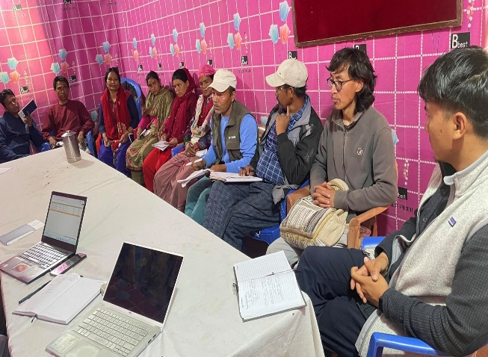
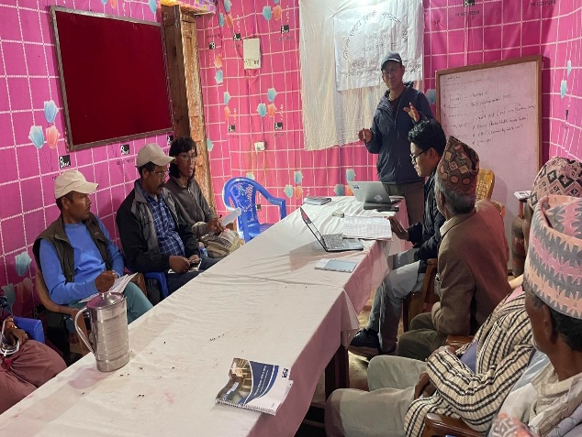
A district-level cooperative network meeting was conducted at Simikot and completed in July 2025. The meeting brought together office staff along with chairpersons and managers from each of the six cooperatives. The agenda focused on identifying key challenges and formulating practical solutions tailored to each cooperative.

1.14 Office equipment and furniture support was provided to cooperatives.
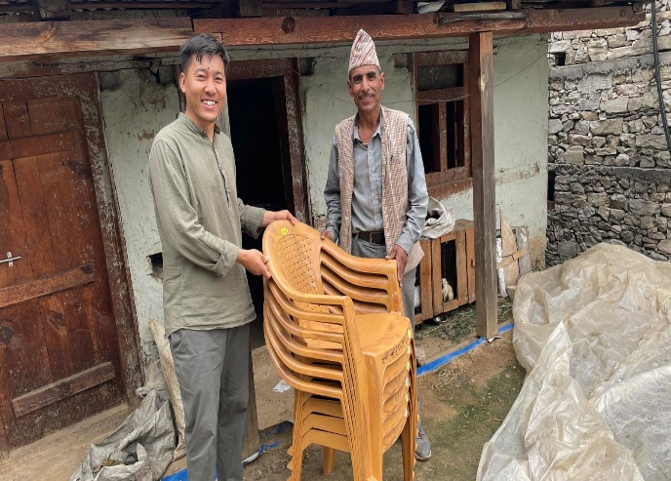
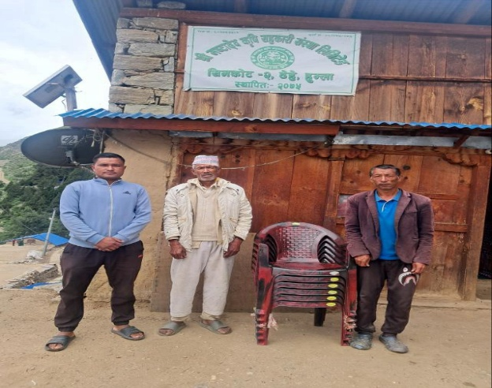
With financial and technical support from Good Neighbors International Nepal and in coordination with Snowland Integrated Development Center (SIDC), support was provided to five cooperatives—Panchamukhi, Dudhkunda, Masthadev, Karnali, and Himali—through the provision of equipment. A total of 40 plastic chairs were supported, and the activity was completed in July 2025
1.15 A cooperative awareness campaign was conducted.
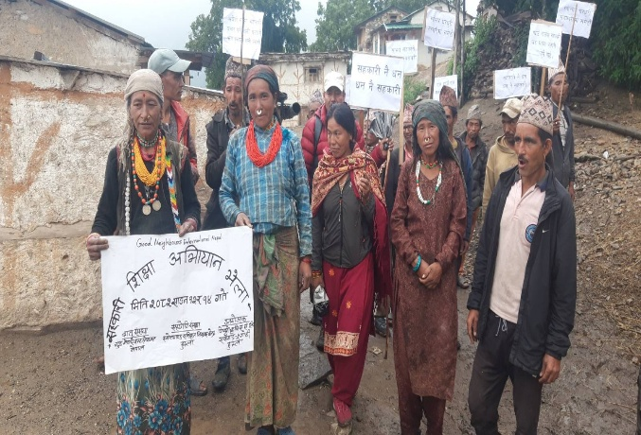
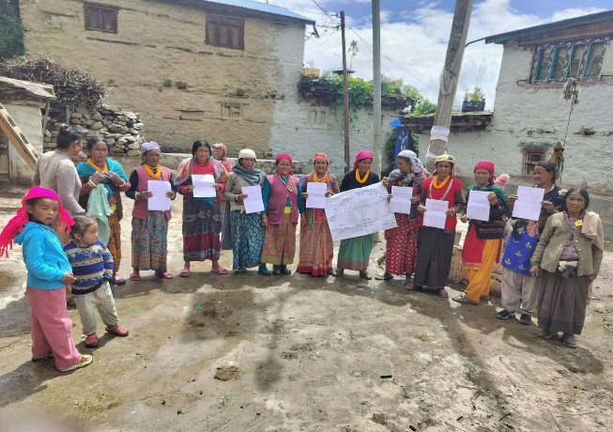
As per the POA 2025, a cooperative awareness program was conducted in all six cooperatives and was completed in July 2025. Each cooperative implemented the campaign at their respective locations, where cooperative members themselves distributed pamphlets with awareness slogans to inform and encourage non-members to join the cooperative as share members.

B. Health and WASH:

2.1 Completed Health and WASH education session at community
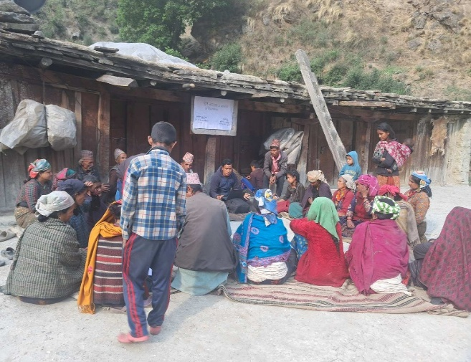
In the past month, health and WASH education sessions were successfully conducted in two Rural municipalities, focusing on Total Sanitation. A total of 108 participants attended these Sessions, including 57 females and 24 males in Sarkegad RM, and 19 females and 8 males in Kharpunath RM. The main objectives of these session were to improve knowledge of hygiene and sanitation practices, promote community awareness and behavior change, enhance skills for monitoring and reporting sanitation progress, and reduce waterborne and airborne diseases Through better hygiene. These initiatives aimed to promote hygiene practices and sanitation Awareness in the communities. Training in both RM was given by our PHO, Mr. Raju Bhandari and were successfully completed in May 2025.
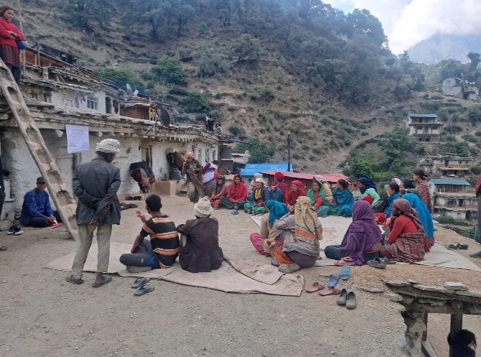

2.2 Completed Training to health workers
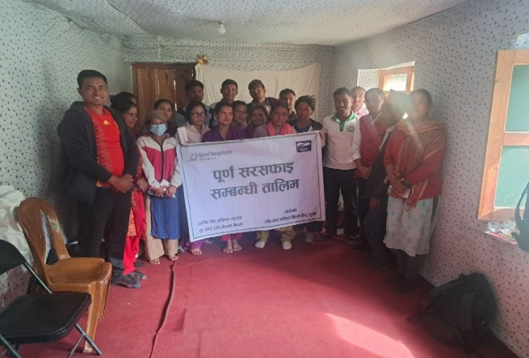
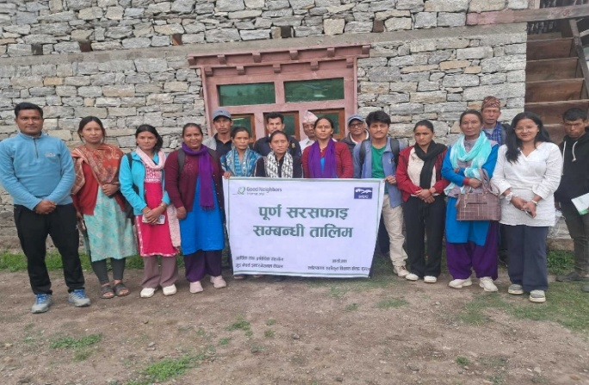
A one-day training on Total Sanitation was given to health workers and related staffs from Sarkegad Rural Municipality and Chankheli Rural Municipality. There were 24 participants from Sarkegad and 20 from Chankheli. The training in both places was conducted by trainer Mrs. Shusila Shah. In Sarkegad, there were 15 male and 9 female participants whereas in Chankheli, there were 12 male and 8 female participants. The training was successfully completed in both rural municipalities. The main objectives of these session were to improve knowledge of hygiene and sanitation practices, promote community awareness and behavior change, enhance skills for monitoring and reporting sanitation progress, and reduce waterborne (diarrhea, cholera, dysentery, jaundice, and typhoid) and airborne diseases (cold, cough, and fever symptoms) Through better hygiene.

2.3 Maintenance works were carried out in three health posts.
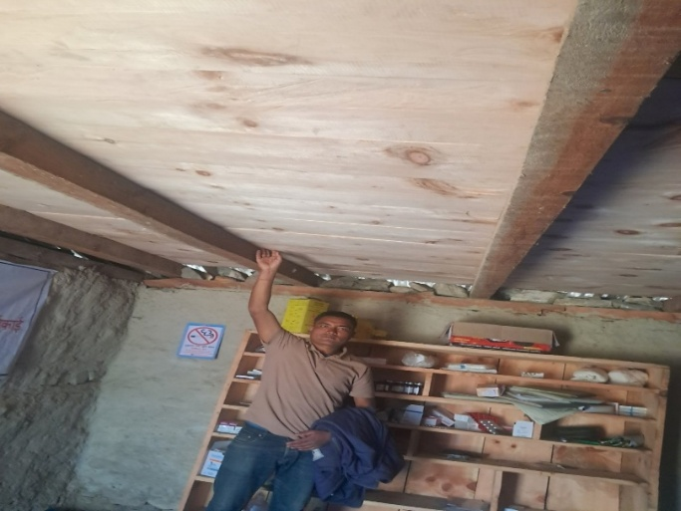
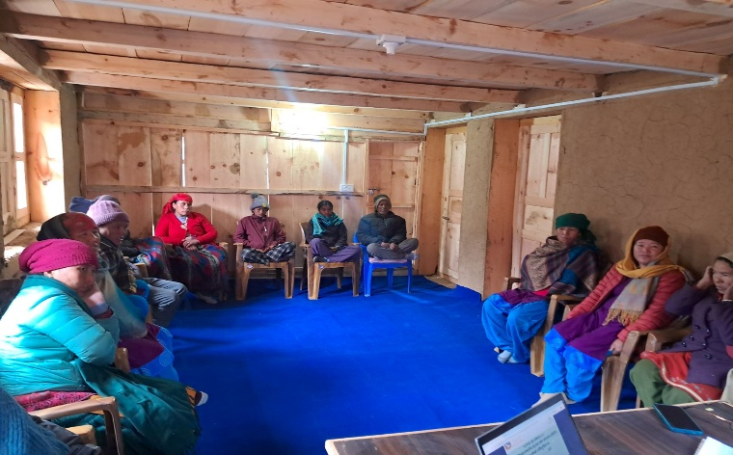
Health post maintenance work was completed in February 2025 at three locations, Bargaun and Burause of Simkot Rural Municipality, and Talka of Kharpunath Rural Municipality. The primary objectives of these renovations were to improve access to quality healthcare by repairing doors and windows, upgrading ceilings and carpeting, and constructing water drainage systems. Specifically, in Burause, the maintenance included door and window repairs, carpeting, and room wiring; in Bargaun, it involved door and window repairs, balcony ceiling work, carpeting, and room wiring; and in Talka, the work focused on door and window repairs, ceiling repairs, carpeting, and the construction of a water drainage system. These improvements aim to ensure that the services provided by these institutions are more efficient, well-organized, and effective, thereby improving the delivery of health services at the community level. Jointly, these health posts serve approximately 506 households, directly benefiting the residents by providing improved healthcare facilities and services.

2.4 General health check-ups were conducted for sponsored children.
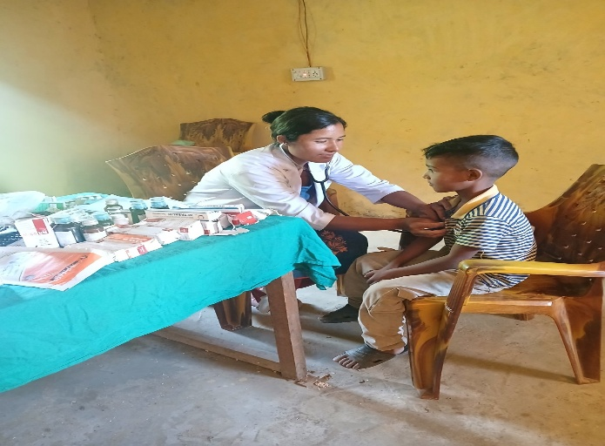
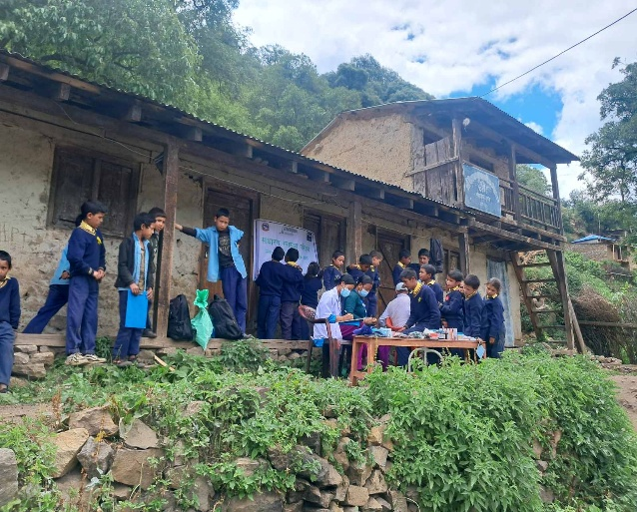
As per the ICDP project requirement, general health check-ups for sponsored children are a mandatory activity. Accordingly, health check-ups for a total of 1,645 children (1,395 existing children and 250 new children) were conducted at 17 Health Posts (HPs) and Community Health Units (CHUs) in coordination with four Rural Municipalities. The main objective of this activity was to screen children and encourage them to visit health institutions at least twice a year, even in the absence of illness, as the project provides annual health equipment support to health institutions to ensure timely health services within the community. This activity was co mpleted in December 2025

2.5 A birthing center was constructed to strengthen health facilities.
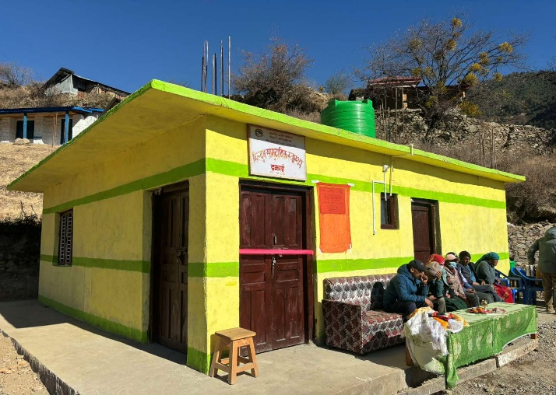
To improve maternal and child healthcare services in the remote community, a birthing center was constructed in Simikot Rural Municipality–4, Hildum. The center provides a safe, hygienic, and well-equipped facility for safe deliveries, and the construction was completed in September 2025.
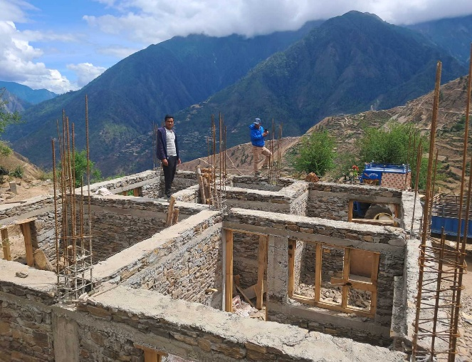

2.6 Basic equipment was supplied to health facilities.
Health equipment support was provided to five health institutions identified through comprehensive needs assessments: Thehe Health Post in Simikot RM; Lali Health Post in Kharpunath RM; Unapani and Rahadev Basic Health Units in Sarkeghat RM; and the Piplang Birthing Center in Chankheli RM. The initiative aimed to enhance community access to healthcare services, enable on-the-spot treatment, and deliver quality care to both sponsored and non-sponsored children and families, while also promoting increased rates of institutional deliveries. The activity was completed in June 2025.
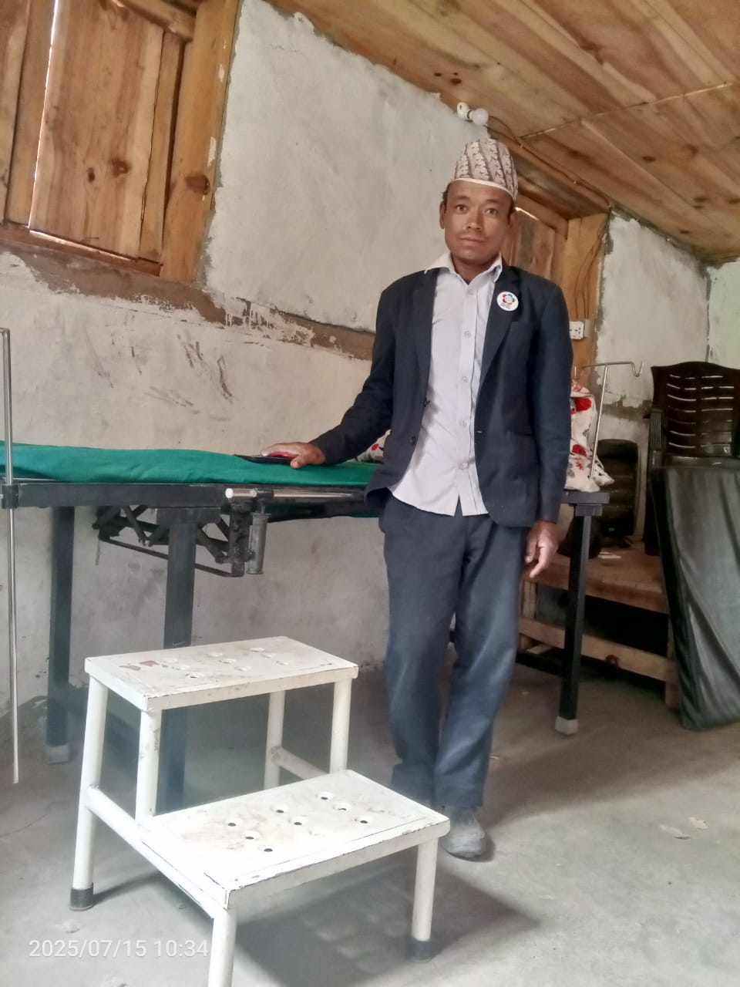
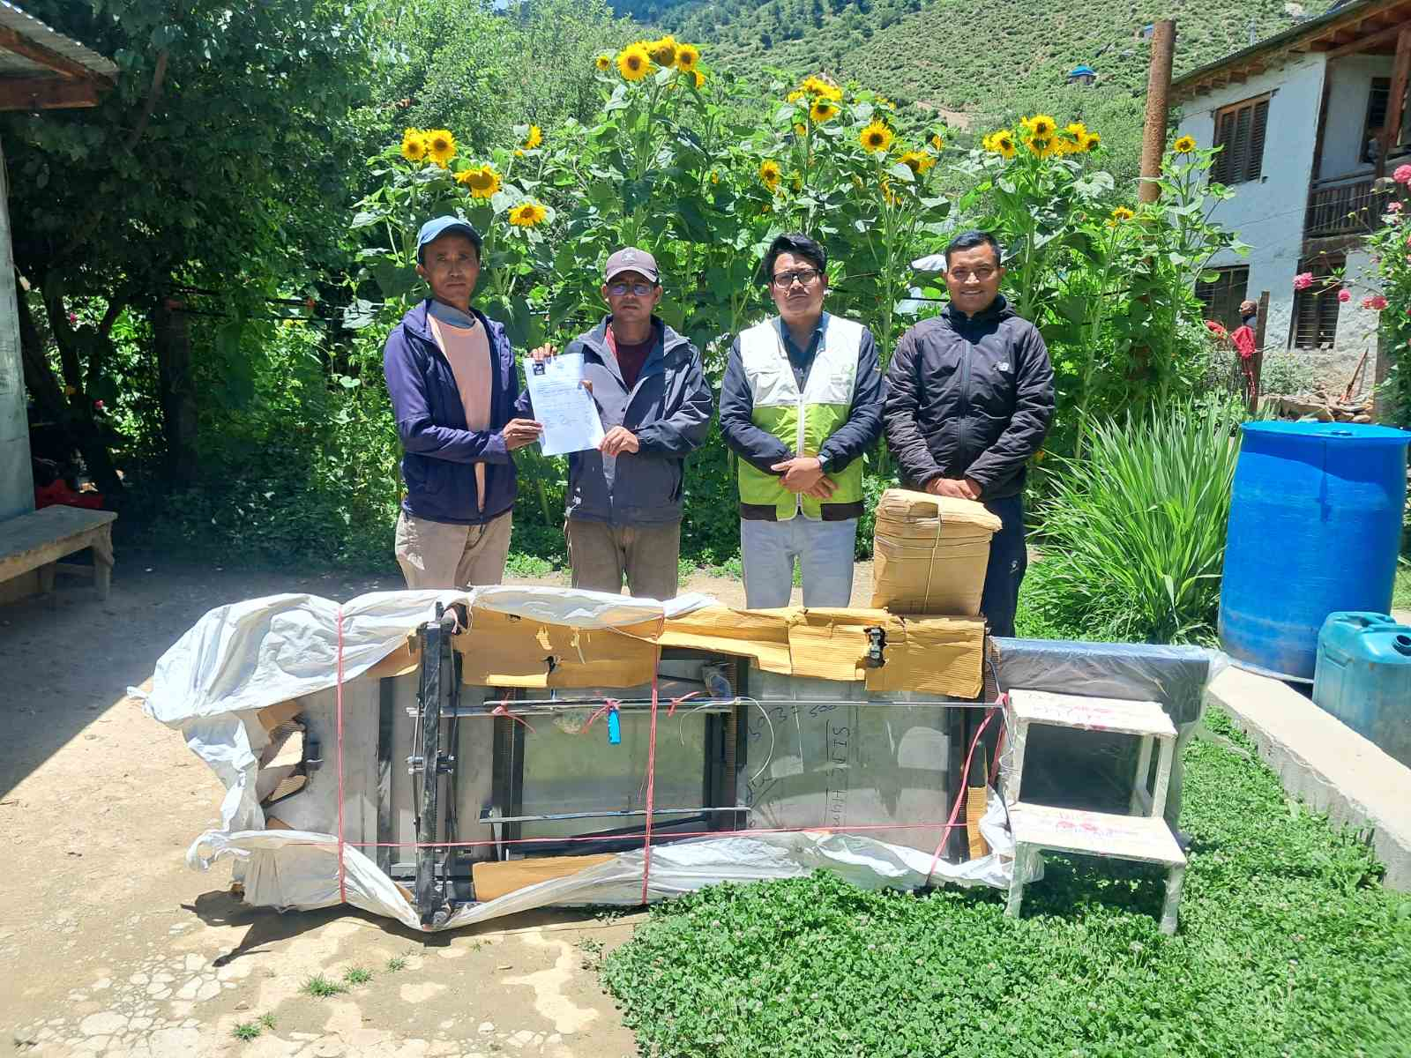

2.7 Utility support was provided to health facilities.
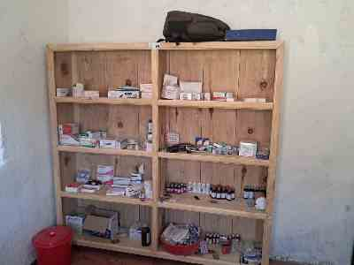
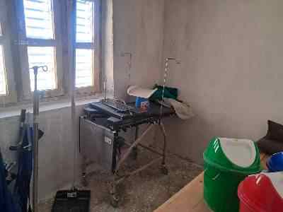
Utility and equipment support comprising 35 items was provided to Hildum CHU following the completion of its construction. The main objective of this support was to ensure timely health checkups for patients within the community. The activity was completed in December 2025.

2.8 Training was provided to HFOMC members.
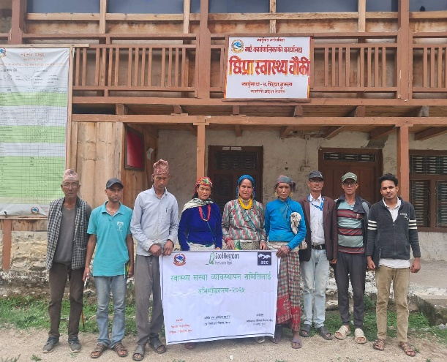
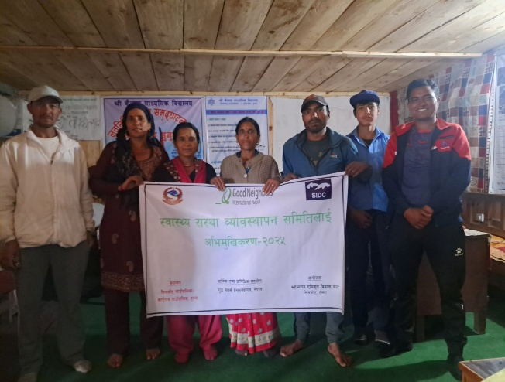
In July 2025, HFOMC orientation was conducted at Chhipra Health Post and Kharpunath Health Post in Kharpunath RM, and at Dadaphaya Health Post in Simikot RM, with the participation of 27 participants. The main objective of the orientation was to strengthen the management and functioning of health facilities.

2.9 An MHM corner was established at Mandhara Secondary school.
In June 2025, an MHM corner was established at Mandhara Secondary School in Kharpunath Rural Municipality. This safe and private space provides adolescent girls with access to menstrual hygiene products, relevant information, and support during menstruation. The initiative aims to help girls remain in school by promoting comfort, confidence, and good health, while ensuring continuity of their education.
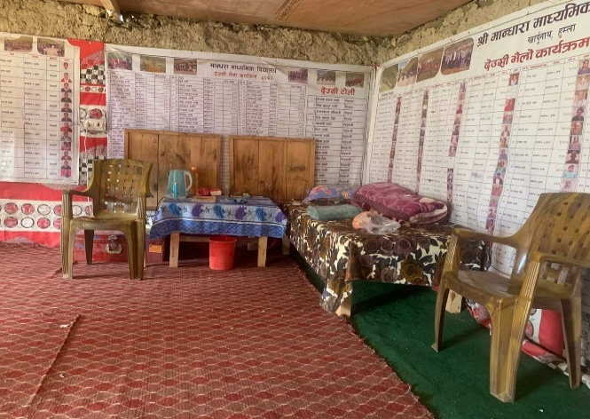
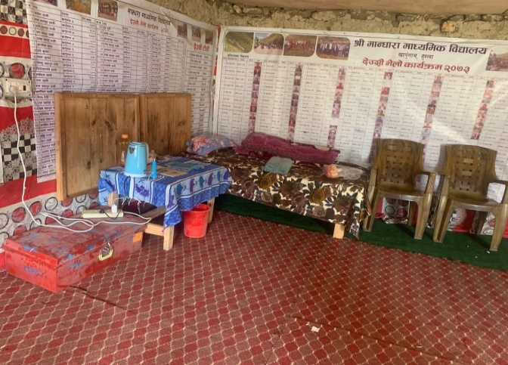
2.10 An MHM-friendly toilet was constructed at the school.
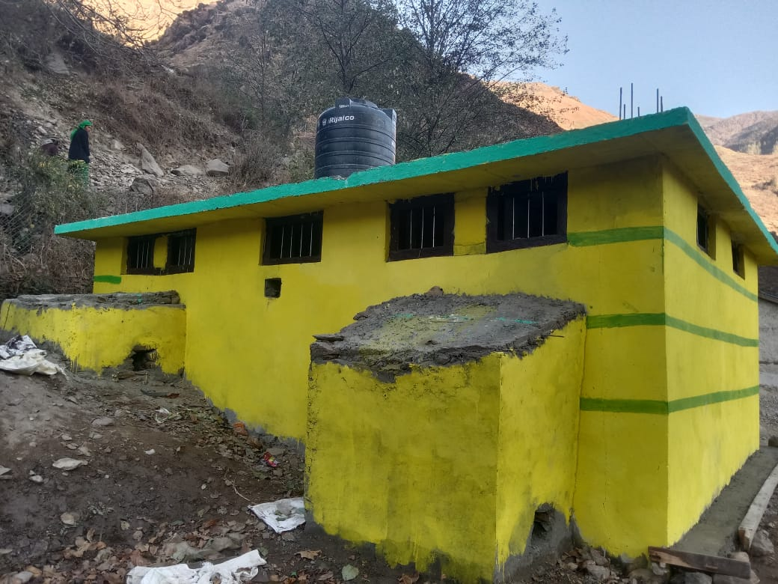
In November 2025, an MHM toilet was constructed at Malika Secondary School, Kharpunath-1, Lali. Due to the lack of a separate toilet, adolescent girls and female teachers had been using an old shared stone toilet, resulting in poor menstrual hygiene practices and increased health risks. To address this issue, SIDC Nepal, in coordination with Kharpunath Rural Municipality and the school, implemented the construction of the MHM toilet, with the Rural Municipality contributing 30% of the total GNI-planned budget for this activity.

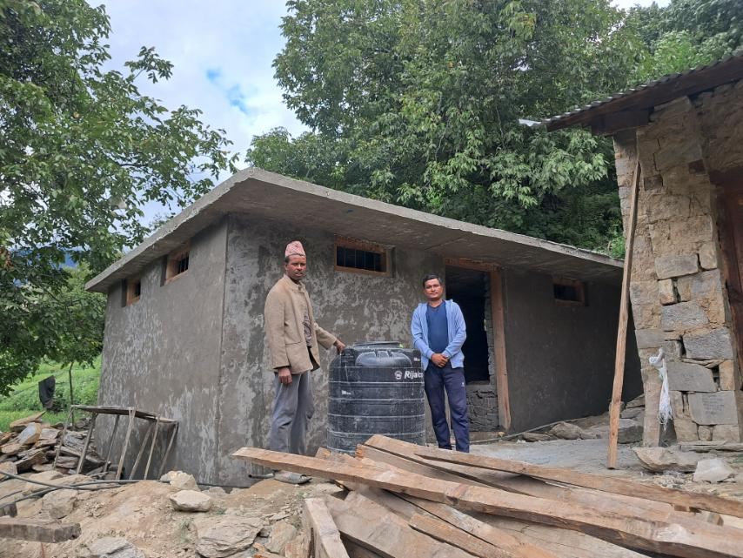
2.11 MHM training sessions were conducted at the school.
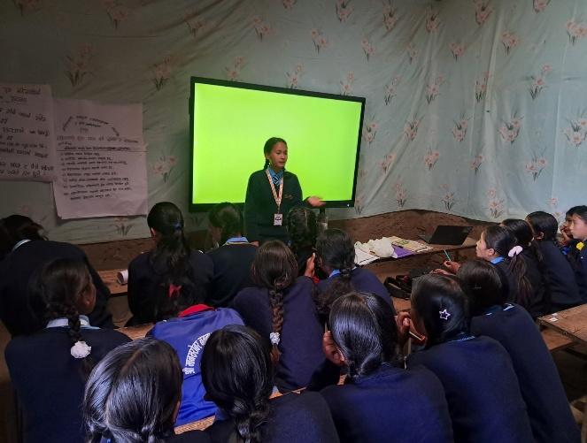
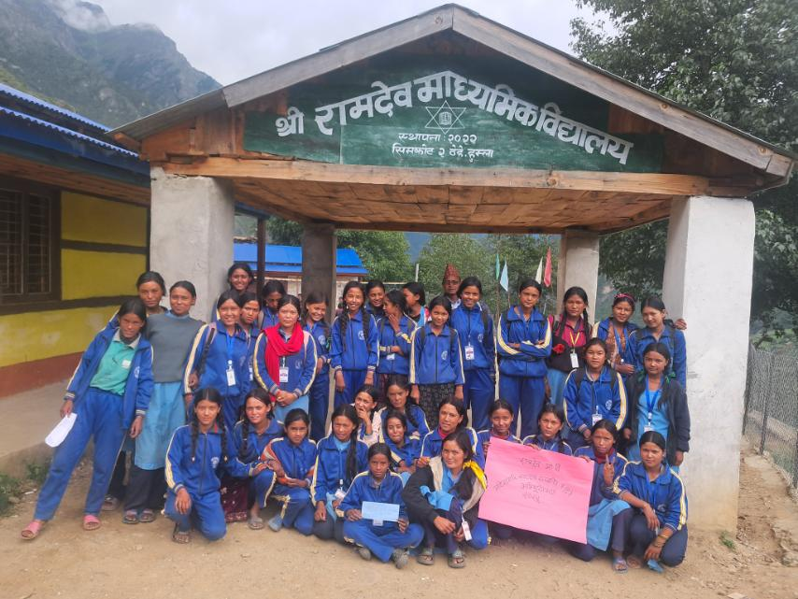
In September 2025, Menstrual Hygiene Management (MHM) orientation sessions were conducted in two schools: Ramdev Secondary School and Mansarobar Secondary School. The orientation aimed to raise awareness among community women and adolescent girls about proper menstrual hygiene practices and to reduce the stigma associated with menstruation. Two sessions were held at Mansarobar Secondary School in Simikot RM, and one session at Ramdev Secondary School.

2.12 Health and WASH education sessions were conducted at the school level.
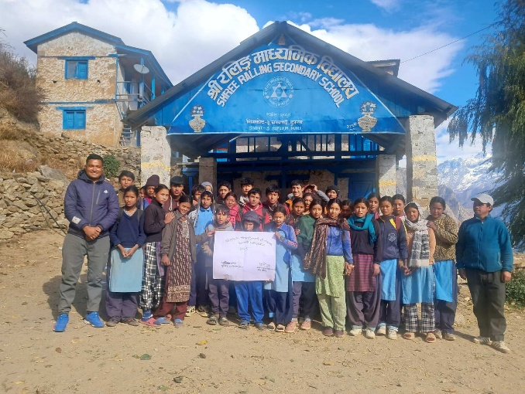
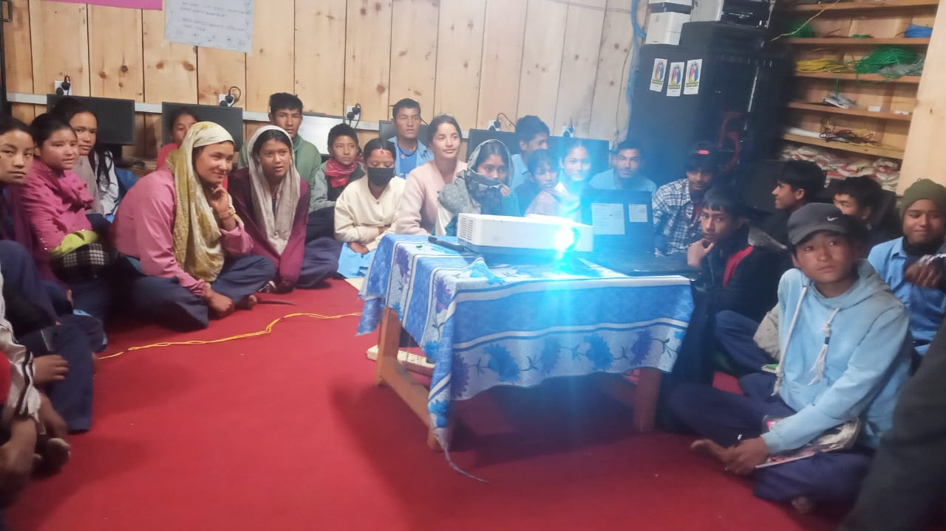
WASH orientation was conducted in five schools, targeting institutions where children face poor sanitation conditions. The program was facilitated by the PHO in two schools and by a designated facilitator in three schools. The activity was completed in November 2025 in the following schools: Mandhara Secondary School, Kharpunath RM; Sita Secondary School, Kharpunath RM; Ralling Secondary School, Simikot RM; Ramdev Secondary School, Simikot RM; and Malika Secondary School, Kharpunath RM.

2.13 FCHVs mobilization
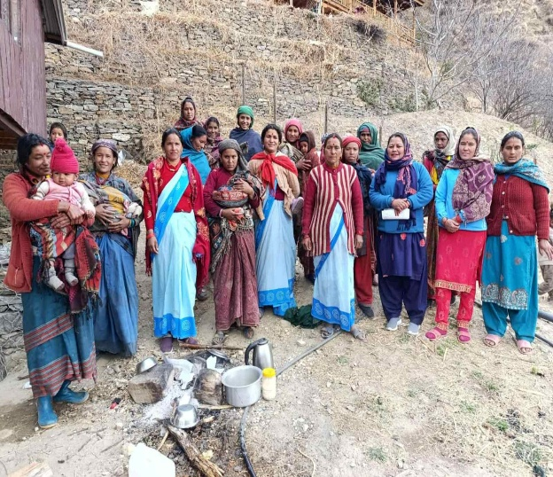
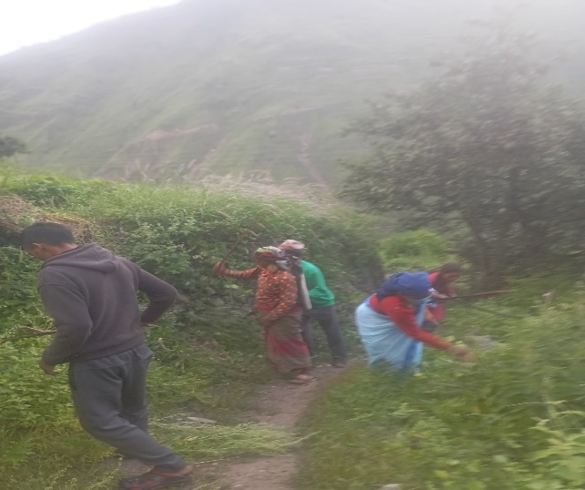
This activity mobilized 27 Female Community Health Volunteers (9 per cluster) in wards 2, 3, 4, and 5 of Kharpunath Rural Municipality to support the smooth operation of Basic Health Units, timely vaccination services, and regular mothers’ group meetings, with the ultimate goal of achieving 100% institutional delivery and improved WASH practices. Implemented in close coordination with the local government, FCHVs conducted monthly activities, maintained records, and submitted reports. The activity ran for four months and was completed in September 2025.

2.14 Training on Health and WASH was provided to FCHVs.
In July 2025, training on total sanitation was conducted for FCHVs at Kharpunath RM, covering Chhipra HP, Raya HP, and Kharpunath HP, with 27 FCHVs participating. The main objective of the orientation was to provide guidance on total sanitation and immunization.
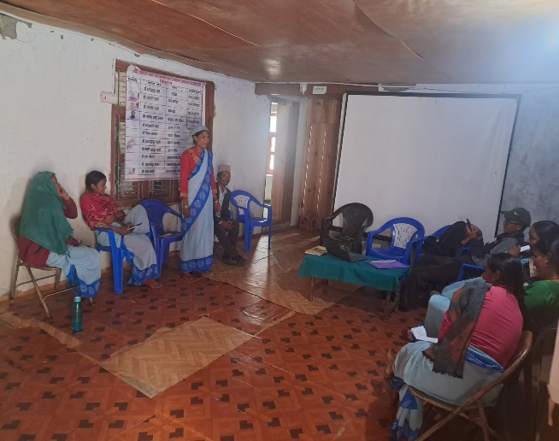
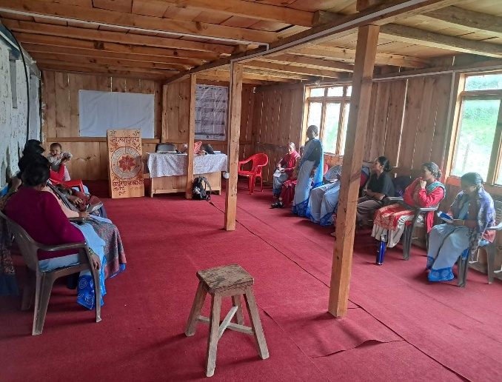

. Cross-Cutting

3.1 Training on Capacity building on climate-smart agriculture to farmers were conducted.
We successfully completed a one-day Climate Smart Agriculture training in May 2025 for 465 farmers across Simikot, Kharpunath, and Sarkegad Rural Municipalities, in partnership with local cooperatives. Led by the JTA and Intern JTA, we introduced practical natural farming techniques—no tillage, Indigenous Microorganisms (IMO), Fermented Fruit/Plant Juices (FFJ/FPJ), mulching, and maintaining nursery fencing—along with nutrient-smart methods such as Oriental Herb Nitrate (OHN) and FAA/KAA for nitrogen, phosphorus, and calcium application. These methods align with recognized climate-smart practices that boost soil moisture, reduce erosion, enhance nutrient cycling, and cut input costs, as promoted by Nepalese cooperatives and agronomic models.
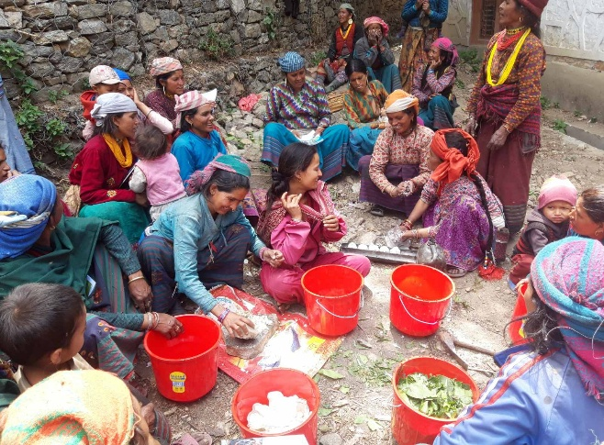
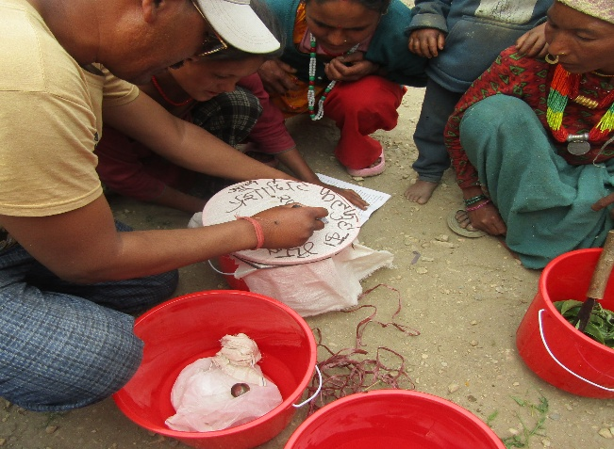

3.2 Natural Farming Demonstration center were formed in 10 places.
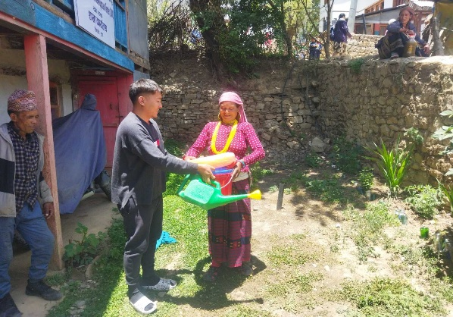
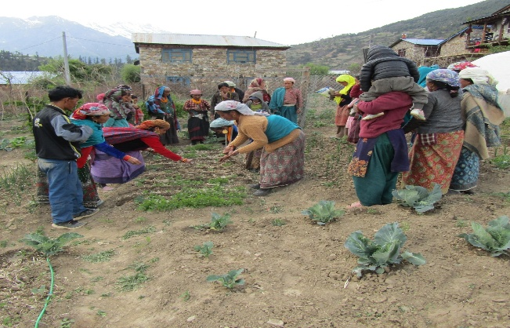
We established Natural Farming Demonstration Centers in 10 locations across four cooperatives, completed in May 2025. Set up at Panchamukhi (Simikot: Hildum & Burause), Mastadev (Thehe), Dudhakunda (Chhipra, Maja, Nalna), and Karnali (Dulli, Mundi, Saya) cooperatives, these centers serve as live learning hubs for natural farming systems. Farmers received necessary agricultural inputs to compare traditional versus natural methods firsthand. The program built their capacity in climate-smart agriculture techniques—no tillage, Indigenous Microorganisms (IMO), Fermented Fruit/Plant Juices (FFJ/FPJ), mulching, and nutrient management using Oriental Herb Nitrate (OHN) and FAA/KAA for nitrogen, phosphorus, and calcium.

D. Non-POA Activities

4.1 Livelihood (In-kind) Support
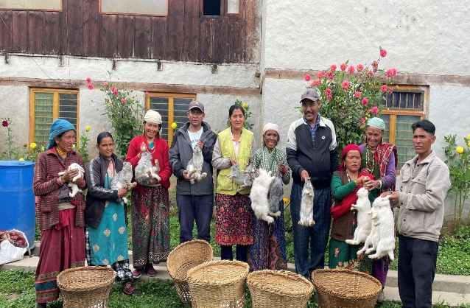
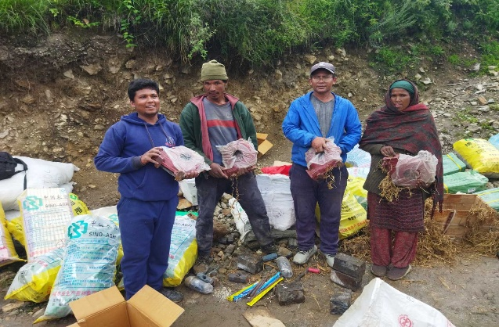
In September 2025, livelihood (in-kind) support was provided with a total budget of NPR 810,000 under the non-POA budget. The initial target was 45 farmers, but the support was successfully expanded to benefit 55 farmers. The distribution included: rabbits to 45 farmers, beekeeping materials to 5 farmers, aran materials to 3 farmers, and retail shop materials to 2 farmers.

4.2 Hygiene kit support

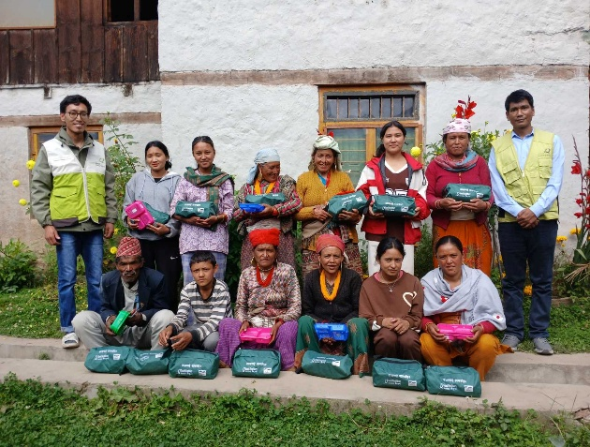
In September 2025, Hygiene kit support was provided to the sponsored children with a total budget of NPR 2,700,095 under Non-POA budget. Each child received the following items: 6 handwashing soaps, 1 nail cutter, 1 glycerin, 2 moisturizers, 2 toothpastes, 3 toothbrushes, 2 hair combs, 1 hair oil, 1 soap case, and 1 hygiene kit bag.
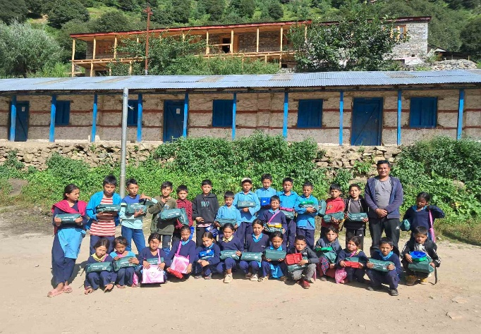

4.3 Critical treatment support

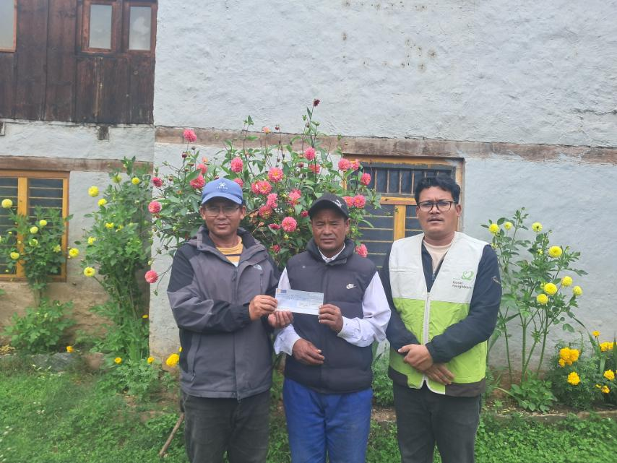
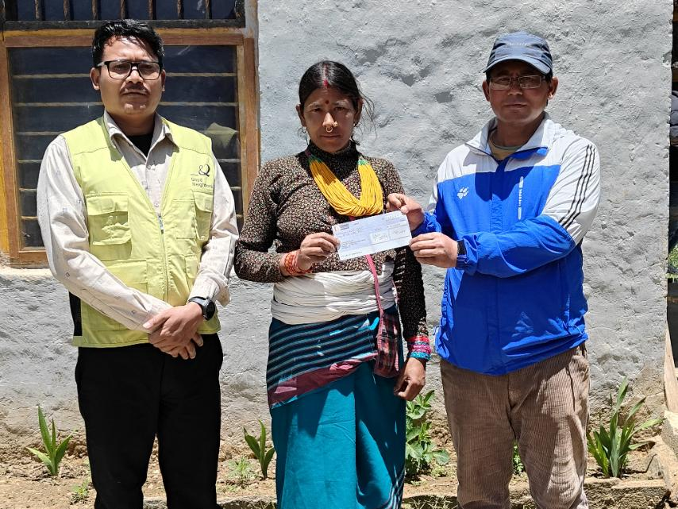
Till December 2025, critical medical treatment support was provided to six children (Male: 5, Female: 1): Suresh Sunar (NPL-0109-004836), Prajowal Bohara (NPL-0109-004492), Kalu Shahi (NPL-0109-004625), Sarmita Bohara (NPL-0109-004836), Bai Bdr Aidi (NPL-0109-005438), and Prabat Chaulagain (NPL-0109-005194). This support was implemented as a non-POA activity, primarily targeting sponsored children from financially poor families, as well as children facing serious health conditions and those affected by natural disasters, with a total expenditure of NPR 247,185 as per the bills submitted.

5. Financial Delivery:
Give details about the financial status of project in the table.
SN | Major Activities | Budget (NRs) |  | Remarks
SN | Major Activities | Plan Budget (POA) | Expenditure | Remarks
2025 (Social Economy, Cross Cutting, Health, wash and Sanitation)
2025-Social Economy
1 | Input support-Apple Farming | 97,350 | 97,295
2 | Training- Apple Farming | 13,950 | 13,945
3 | Cooperative Management Support | 2,52,000 | 2,52,000
4 | Eco Friendly School Kitchen Garden | 2,50,000 | 2,49,930
5 | Vegetable and Apple Dryer | 96,000 | 96,000
6 | Collection Center Establishment | 2,00,000 | 2,00,000
7 | Small Irrigation Scheme | 3,94,280 | 3,94,280
8 | Training- Entrepreneurship | 16,400 | 16,400
9 | Input and farming accessories support | 11,27,824 | 11,27,824
10 | Market Actor Coordination Meeting | 60,600 | 60,600
11 | Cooperative Business Management Training | 93,760 | 93,760
12 | Cooperative Accounting Software Renewal (AMC) cost | 48,000 | 24,000
13 | District Level Cooperative Network Meeting | 56,460 | 56,460
14 | Office equipment and furniture support to cooperative | 43,200 | 43,200
15 | Cooperative awareness campaign | 24,000 | 24,000
2025-Health & WASH
1 | General health check-up of sponsored children | 3,02,680 | 3,02,635.7
2 | Construction of health facilities (Birthing center) | 24,00,000 | 24,00,000
3 | Basic equipment support to health facilities | 1,76,190 | 1,76,164
4 | Utility support to health facilities | 1,62,894 | 1,62,819
5 | Training to HFOMC members | 17,070 | 14,035
6 | Training to health workers | 1,25,700 | 1,25,900
7 | Establishment of MHM corner at school | 50,000 | 50,000
8 | Construction of MHM friendly toilet at school | 16,84,000 | 16,84,000
9 | Training on MHM at school | 14,100 | 14,070
10 | Conduct health and WASH education session at community | 31,800 | 31,795
11 | Conduct health and WASH education session at school | 45,300 | 45,300
12 | Training to FCHV on Health & WASH | 26,200 | 25,245
13 | FCHV mobilization | 45,000 | 44,955
14 | Health post Maintenance | 7,35,000 | 7,34,951.50
2025-Cross Cutting
1 | Capacity building on climate-smart agriculture to farmers | 2,54,280 | 2,11,175
2 | Natural Farming Demonstration center | 40,000 | 39,990
2025-Non-POA Activities
1 | Livelihood (In-kind) Support | 8,10,000 | 8,10,000
2 | Hygiene kit support | 2700095 | 2700095
3 | Critical treatment support | 247185 | 247185
 | Total Amount | 1,26,41,318 | 1,26,41,318
Note: The above expenditure includes expenses from January to December 2025 for both POA and non-POA activities of the Livelihood and Health & WASH programs.

6. Lesson Learned:
- When handing over equipment and other materials, they should be provided only to responsible persons to prevent loss or damage.
- Field staff should regularly update their supervisors on ongoing programs and their assigned responsibilities.
- Learning centers should be established in all locations to build farmers’ skills and confidence.
- Mandatory monitoring of all cooperatives should be conducted once every two months.
- Collection centers are important in every location.
- Quotation and vendor selection should be completed on time.
- District-level staff should conduct frequent monitoring.

7. Issues and Challenges:

- Due to low DSA for field staff, we are facing difficulties in covering field expenses amid rising inflation.
- Lack of training among field- and district-level staff.
- Delayed approval of the POA.
- High turnover of trained cooperative managers.
- Internet and communication problems.
- In some cooperatives, RF return funds were withheld by chairpersons and not deposited into the cooperative account, indicating weak financial accountability.
- Due to the cooperative manager’s low academic qualification, managing internal and external funds has become difficult.
- Difficulty in transporting farmers’ produce to limited markets.
- Low snack has raised problem in gathering participants.
- Transportation problems.

8. Way forward
- Develop a plan to monitor the effective implementation of each activity.
- Cooperative managers should be trained three times a year on reporting.
- Monthly bank statements for both internal and revolving funds should be collected.
- Conduct general health checkups for both sponsored and non-sponsored children, if possible.
- When handing over farming accessories and other materials, they should be given only to responsible persons to prevent loss or damage.
- Quotation and vendor selection should be completed on time.
- The program should be monitored regularly to ensure effective implementation.

